**Experiment -1.2**

**Student Name:** Atinshay Awasthi **UID:** 22BDO10007

**Branch:** CSE-DevOps **Section/Group:** 22BCD-1/A

**Semester:** 4th **Date of Performance:**24/1/24

**Subject Name:** Git And Github **Subject Code:**22CSH-293

## 1. Aim/Overview of the practical: Creating branches with GitHub

**2. Task to be done:** Creating branches with GitHub and on Git Bash.

**3. Apparatus:** software used git hub and git bash

**4. Steps for experiment/practical:**

**Creating Branch on GitHub :**

1. Open your Github and go into repository “Demo” you want branching.
2. Add new file in that named “first file” , and after this just write the code,

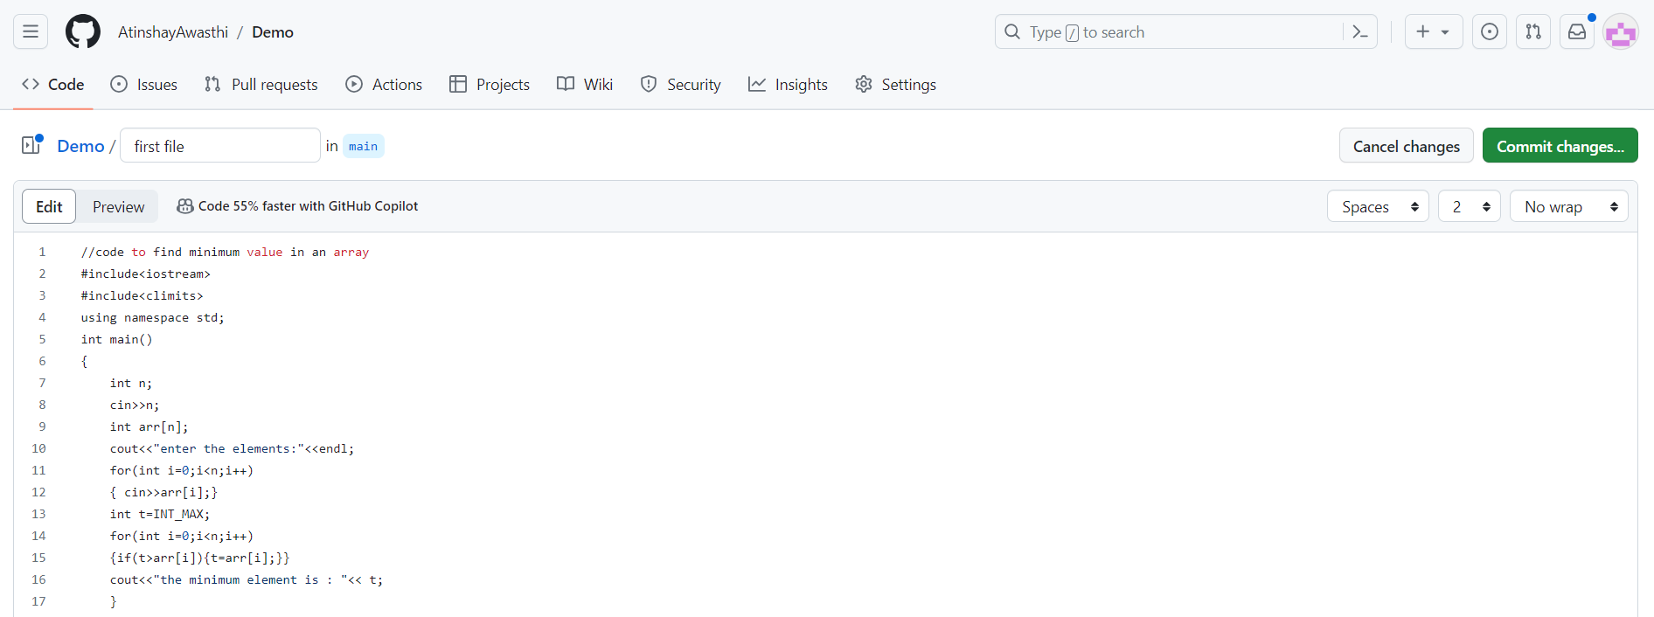

1. After that click on “commit change” , and give commit message and description, then click on Commit Changes.

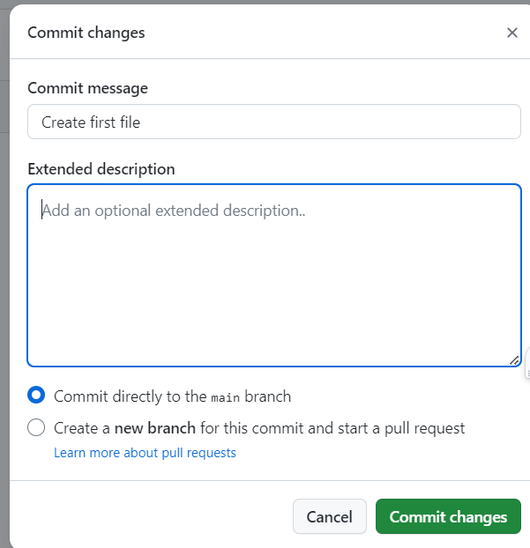

1. Then open the “first file” and click on **“main”** to create branch.
2. In main go on “view all branches” and click on **‘New Branch’** ,then enter the name of branch **‘branching’** and the click on **create new branch.**

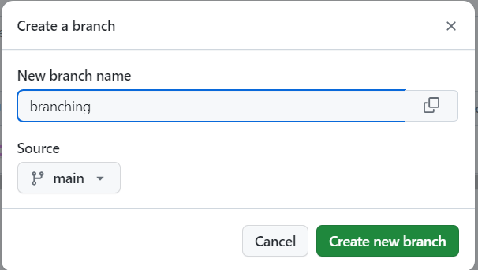

1. Now in the file go on ‘edit the file’ and edit the code.

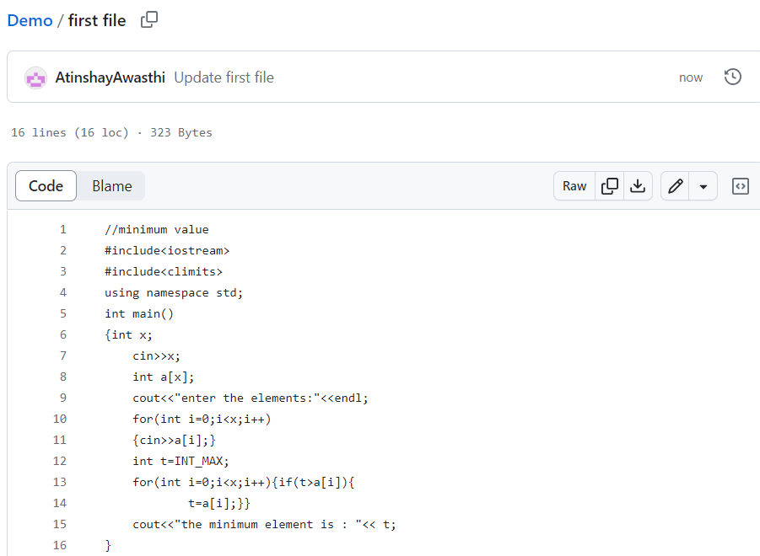

1. After edit the code then click on **‘commit changes’** to commit the changes , enter commit message and the description.

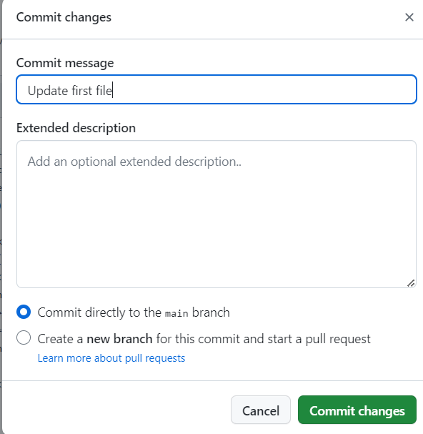

1. Then in the repository go on “**compare & pull request”.**
2. Here is the code comparation in split form.

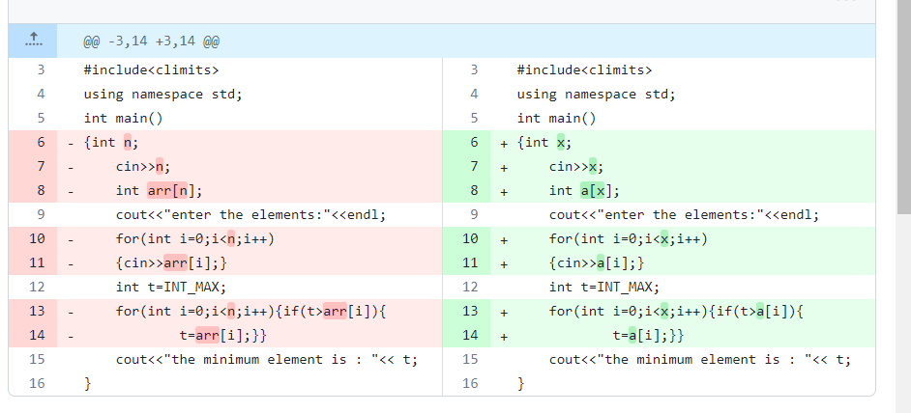

1. Then click on **‘Create pull request’** , and give tittle and description.

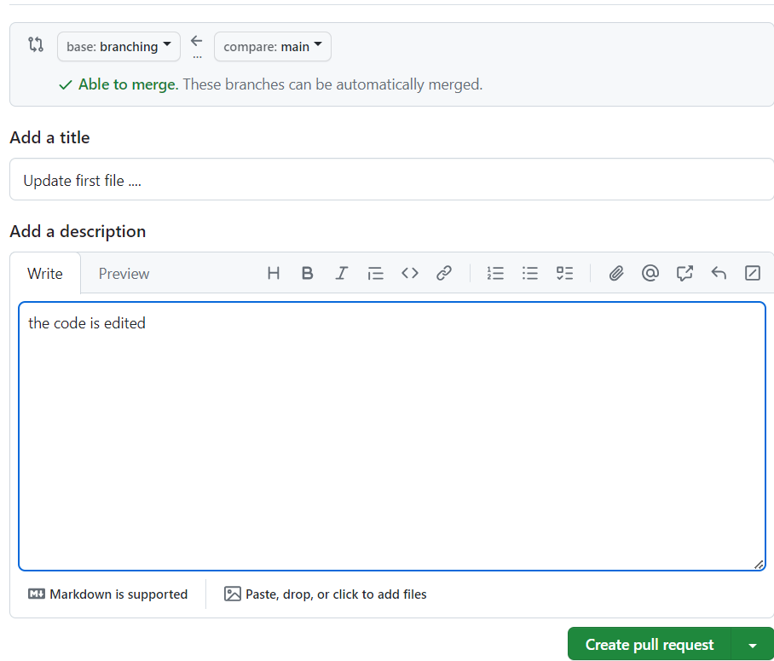

1. After this click on **merge pull request**.And **confirm merge.**

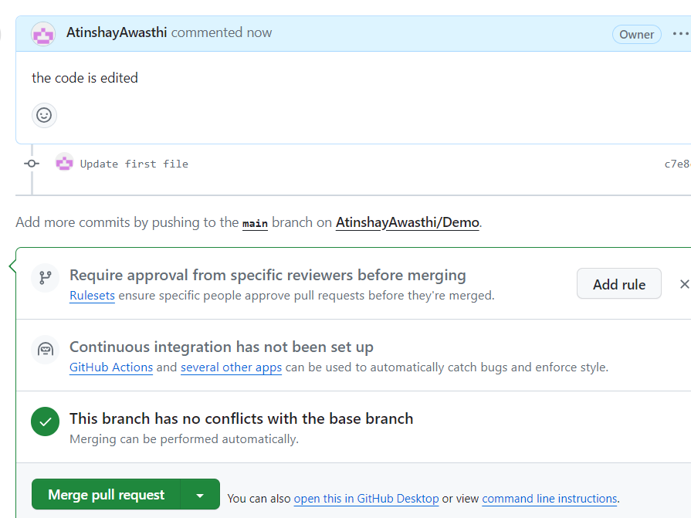

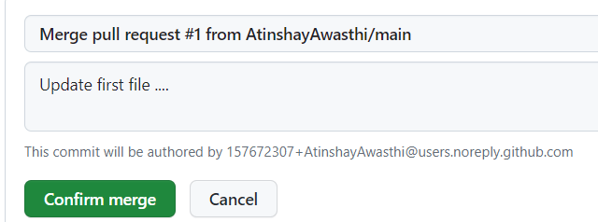

1. If you want to delete the branch so you can delete by clicking on ‘Delete branch’.

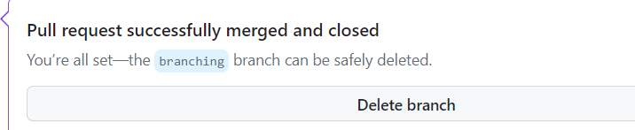

**Creating Branch on Git Bash :**

1. First we create a new folder on desktop named ‘git’.
2. After that we initialize it using **‘git init’command.**
3. Then create a new file using command **‘vi atinshay’**.
4. Edit the file .

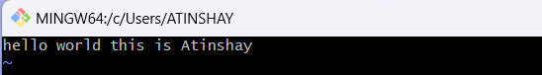

1. Using command **‘git add(atinshay)’** we put it in staging area.
2. Now create a branch using ‘git checkout -b branch_name’ **, git checkout -b newbranch.**
3. Now again edit the file using **‘vi atinshay’.**

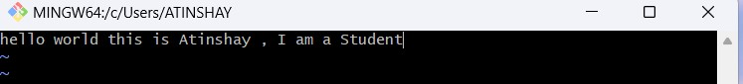

1. Using command **‘git add(atinshay)’** we put it in staging area.
2. Commit it using git commit -m “message” .
3. Use “git checkout master ” to move it in a master branch.
4. Merge branch using ‘git merge newbranch’.

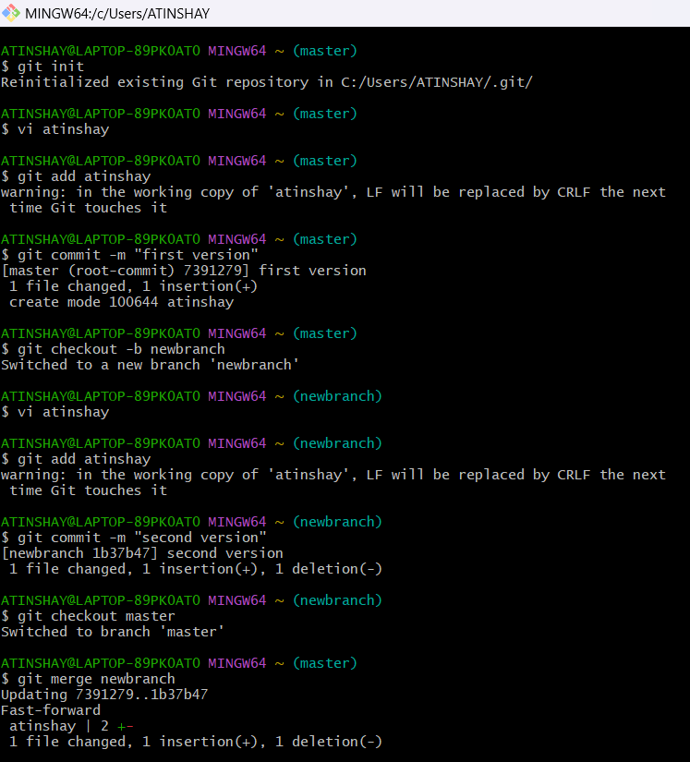

**5. Result/Output/Writing Summary:**

In this experiment we have successfuly created a branch on Github and Gitbash.

**6. Learning outcomes (What I have learnt):**

**1.** I have learnt about Branches.

**2.** I have learnt about the process of creating branch on github.

**3.** I have learnt about various commands like ‘**git init’** ‘**git add(file_name)**’ ,‘**git checkout -b branch_name**’, ‘**git commit -m “message**”, “**git checkout master** ”, ‘**git merge newbranch’, ‘git status’**.

**4.** I have learnt about how to add file.

**5.** I have learnt about

**Evaluation Grid (To be created as per the SOP and Assessment guidelines by the faculty):**

|  |  |  |  |
| --- | --- | --- | --- |
| Sr. No. | Parameters | Marks Obtained | Maximum Marks |
| 1. |  |  |  |
| 2. |  |  |  |
| 3. |  |  |  |
|  |  |  |  |